**12/08/2024 JAVA-CSA0983**

**1] Helloworld button**

package javafxapplication1;

import javafx.application.Application;

import javafx.event.ActionEvent;

import javafx.event.EventHandler;

import javafx.scene.Scene;

import javafx.scene.control.Button;

import javafx.scene.layout.StackPane;

import javafx.stage.Stage;

public class JavaFXApplication1 extends Application {

@Override

public void start(Stage primaryStage) {

Button btn = new Button();

btn.setText("Say 'Hello World'");

btn.setOnAction(new EventHandler<ActionEvent>() {

@Override

public void handle(ActionEvent event) {

System.out.println("Hello World!");

}

});

StackPane root = new StackPane();

root.getChildren().add(btn);

Scene scene = new Scene(root, 300, 250);

primaryStage.setTitle("Hello World!");

primaryStage.setScene(scene);

primaryStage.show();

}

public static void main(String[] args) {

launch(args);

}

}

**Output:**

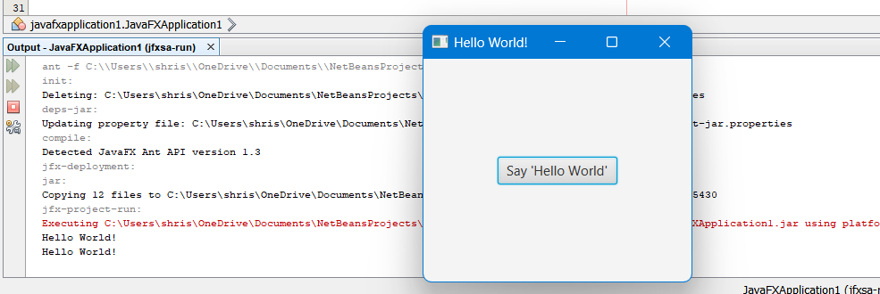

**2] Circle with colour**

package javafxapplication1;

import javafx.application.Application;

import javafx.scene.Scene;

import javafx.scene.layout.StackPane;

import javafx.scene.paint.Color;

import javafx.scene.shape.Circle;

import javafx.stage.Stage;

public class JavaFXApplication1 extends Application {

@Override

public void start(Stage primaryStage) {

Circle circle = new Circle(50);

circle.setFill(Color.BLUE);

circle.setStroke(Color.BLACK);

circle.setStrokeWidth(2);

StackPane root = new StackPane();

root.getChildren().add(circle);

Scene scene = new Scene(root, 300, 250);

primaryStage.setTitle("Circle");

primaryStage.setScene(scene);

primaryStage.show();

}

public static void main(String[] args) {

launch(args);

}

}

**Output:**

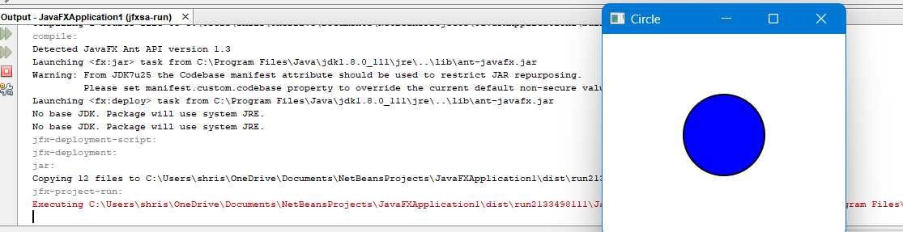

**3] Circle without color**

package javafxapplication1;

import javafx.application.Application;

import javafx.scene.Scene;

import javafx.scene.layout.StackPane;

import javafx.scene.paint.Color;

import javafx.scene.shape.Circle;

import javafx.stage.Stage;

public class JavaFXApplication1 extends Application {

@Override

public void start(Stage primaryStage) {

Circle circle = new Circle(50);

circle.setCenterX(150);

circle.setCenterY(125);

circle.setStroke(Color.BLACK);

circle.setStrokeWidth(2);

circle.setFill(null);

StackPane root = new StackPane();

root.getChildren().add(circle);

Scene scene = new Scene(root, 300, 250);

primaryStage.setTitle("Circle");

primaryStage.setScene(scene);

primaryStage.show();

}

public static void main(String[] args) {

launch(args);

}

}

**Output:**

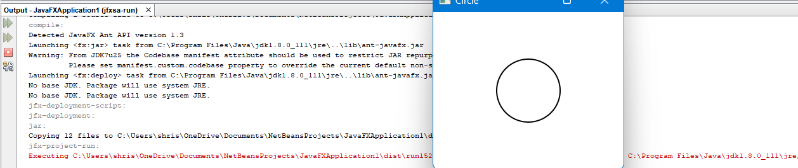

**4] rectangle without colour**

package javafxapplication1;

import javafx.application.Application;

import javafx.scene.Scene;

import javafx.scene.layout.StackPane;

import javafx.scene.paint.Color;

import javafx.scene.shape.Rectangle;

import javafx.stage.Stage;

public class JavaFXApplication1 extends Application {

@Override

public void start(Stage primaryStage) {

Rectangle rectangle = new Rectangle(50, 50, 150, 75);

rectangle.setFill(null);

rectangle.setStroke(Color.BLACK);

rectangle.setStrokeWidth(5);

StackPane root = new StackPane();

root.getChildren().add(rectangle);

Scene scene = new Scene(root, 300, 250);

primaryStage.setTitle("Rectangle");

primaryStage.setScene(scene);

primaryStage.show();

}

public static void main(String[] args) {

launch(args);

}

}

**Output:**

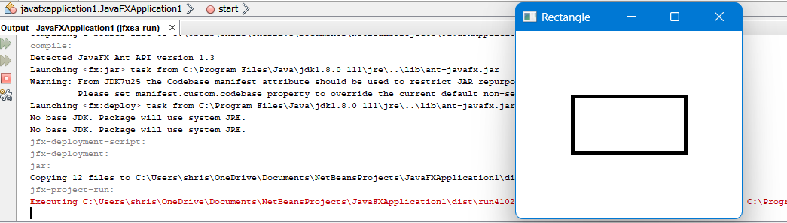

**5] Rectangle with colour**

package javafxapplication1;

import javafx.application.Application;

import javafx.scene.Scene;

import javafx.scene.layout.StackPane;

import javafx.scene.paint.Color;

import javafx.scene.shape.Rectangle;

import javafx.stage.Stage;

public class JavaFXApplication1 extends Application {

@Override

public void start(Stage primaryStage) {

Rectangle rectangle = new Rectangle(50, 50, 150, 75);

rectangle.setFill(Color.PURPLE);

rectangle.setStroke(Color.BLACK);

rectangle.setStrokeWidth(5);

StackPane root = new StackPane();

root.getChildren().add(rectangle);

Scene scene = new Scene(root, 300, 250);

primaryStage.setTitle("Rectangle");

primaryStage.setScene(scene);

primaryStage.show();

}

public static void main(String[] args) {

launch(args);

}

}

**Output:**

